# Tiempos y Resolución

## Algoritmo hyperband

n_days 28 {'units': 416, 'lr': 0.0015323427281788212, 'dropout': 0.1, 'recurrent_dropout': 0.1, 'batch_size': 32, 'tuner/epochs': 17, 'tuner/initial_epoch': 6, 'tuner/bracket': 2, 'tuner/round': 1, 'tuner/trial_id': '0053'}

otro 28 <class '__main__.MyTuner'>

Results summary

Results in /content/drive/MyDrive/a Tesis de Grado/Tesis Versiones/tesis2023/modelos /salidasModelosHypertuner/hyperband/SMAPE-max_trials50- epochs100-aleatorio 28

Showing 1 best trials

Objective(name="val_loss", direction="min")

Trial 0068 summary

Hyperparameters:

units: 416

lr: 0.0015323427281788212

dropout: 0.1

recurrent_dropout: 0.1

batch_size: 32

tuner/epochs: 17

tuner/initial_epoch: 6

tuner/bracket: 2

tuner/round: 1

tuner/trial_id: 0053

Score: 0.07861421257257462

results_summary <class 'NoneType'>

EarlyStopping patience

Basicamente es una x cantidad de épocas que el si no mejora el performance-rendimiento del modelo durante el entrenamiento se corta, deja de entrenar, esto para evitar el overfitting.

EarlyStopping patience=50 antes era 10(buscar papers de justificación)

Epochs 150

Tiempo inicio 15:45 07-10-2023

Finalizo a las 15:56

Se corta en epoch 107

Cuestiones generales

!df -h

Filesystem Size Used Avail Use% Mounted on

overlay 79G 27G 52G 34% /

tmpfs 64M 0 64M 0% /dev

shm 5.7G 0 5.7G 0% /dev/shm

/dev/root 2.0G 1.1G 885M 55% /usr/sbin/docker-init

tmpfs 6.4G 104K 6.4G 1% /var/colab

/dev/sda1 50G 29G 22G 58% /opt/bin/.nvidia

tmpfs 6.4G 0 6.4G 0% /proc/acpi

tmpfs 6.4G 0 6.4G 0% /proc/scsi

tmpfs 6.4G 0 6.4G 0% /sys/firmware

drive 15G 7.9G 7.2G 53% /content/drive

!cat /proc/cpuinfo

processor : 0

vendor_id : GenuineIntel

cpu family : 6

model : 63

model name : Intel(R) Xeon(R) CPU @ 2.30GHz

stepping : 0

microcode : 0xffffffff

cpu MHz : 2299.998

cache size : 46080 KB

physical id : 0

siblings : 2

core id : 0

cpu cores : 1

apicid : 0

initial apicid : 0

fpu : yes

fpu_exception : yes

cpuid level : 13

wp : yes

flags : fpu vme de pse tsc msr pae mce cx8 apic sep mtrr pge mca cmov pat pse36 clflush mmx fxsr sse sse2 ss ht syscall nx pdpe1gb rdtscp lm constant_tsc rep_good nopl xtopology nonstop_tsc cpuid tsc_known_freq pni pclmulqdq ssse3 fma cx16 pcid sse4_1 sse4_2 x2apic movbe popcnt aes xsave avx f16c rdrand hypervisor lahf_lm abm invpcid_single ssbd ibrs ibpb stibp fsgsbase tsc_adjust bmi1 avx2 smep bmi2 erms invpcid xsaveopt arat md_clear arch_capabilities

bugs : cpu_meltdown spectre_v1 spectre_v2 spec_store_bypass l1tf mds swapgs mmio_stale_data retbleed

bogomips : 4599.99

clflush size : 64

cache_alignment : 64

address sizes : 46 bits physical, 48 bits virtual

power management:

processor : 1

vendor_id : GenuineIntel

cpu family : 6

model : 63

model name : Intel(R) Xeon(R) CPU @ 2.30GHz

stepping : 0

microcode : 0xffffffff

cpu MHz : 2299.998

cache size : 46080 KB

physical id : 0

siblings : 2

core id : 0

cpu cores : 1

apicid : 1

initial apicid : 1

fpu : yes

fpu_exception : yes

cpuid level : 13

wp : yes

flags : fpu vme de pse tsc msr pae mce cx8 apic sep mtrr pge mca cmov pat pse36 clflush mmx fxsr sse sse2 ss ht syscall nx pdpe1gb rdtscp lm constant_tsc rep_good nopl xtopology nonstop_tsc cpuid tsc_known_freq pni pclmulqdq ssse3 fma cx16 pcid sse4_1 sse4_2 x2apic movbe popcnt aes xsave avx f16c rdrand hypervisor lahf_lm abm invpcid_single ssbd ibrs ibpb stibp fsgsbase tsc_adjust bmi1 avx2 smep bmi2 erms invpcid xsaveopt arat md_clear arch_capabilities

bugs : cpu_meltdown spectre_v1 spectre_v2 spec_store_bypass l1tf mds swapgs mmio_stale_data retbleed

bogomips : 4599.99

clflush size : 64

cache_alignment : 64

address sizes : 46 bits physical, 48 bits virtual

power management:

!cat /proc/meminfo

MemTotal: 13294208 kB

MemFree: 9344460 kB

MemAvailable: 11738908 kB

Buffers: 74368 kB

Cached: 2517880 kB

SwapCached: 0 kB

Active: 754572 kB

Inactive: 2905412 kB

Active(anon): 1072 kB

Inactive(anon): 1068008 kB

Active(file): 753500 kB

Inactive(file): 1837404 kB

Unevictable: 12 kB

Mlocked: 12 kB

SwapTotal: 0 kB

SwapFree: 0 kB

Dirty: 13096 kB

Writeback: 0 kB

AnonPages: 1067780 kB

Mapped: 568824 kB

Shmem: 1320 kB

KReclaimable: 88996 kB

Slab: 129024 kB

SReclaimable: 88996 kB

SUnreclaim: 40028 kB

KernelStack: 6096 kB

PageTables: 21572 kB

NFS_Unstable: 0 kB

Bounce: 0 kB

WritebackTmp: 0 kB

CommitLimit: 6647104 kB

Committed_AS: 2967728 kB

VmallocTotal: 34359738367 kB

VmallocUsed: 74904 kB

VmallocChunk: 0 kB

Percpu: 1320 kB

HardwareCorrupted: 0 kB

AnonHugePages: 0 kB

ShmemHugePages: 0 kB

ShmemPmdMapped: 0 kB

FileHugePages: 0 kB

FilePmdMapped: 0 kB

CmaTotal: 0 kB

CmaFree: 0 kB

HugePages_Total: 0

HugePages_Free: 0

HugePages_Rsvd: 0

HugePages_Surp: 0

Hugepagesize: 2048 kB

Hugetlb: 0 kB

DirectMap4k: 162616 kB

DirectMap2M: 5076992 kB

DirectMap1G: 10485760 kB

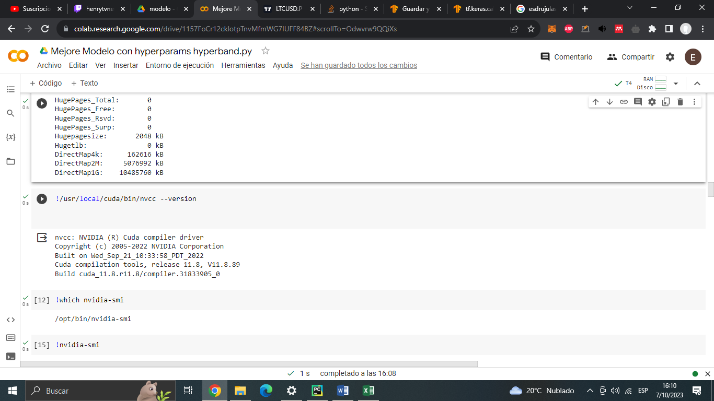

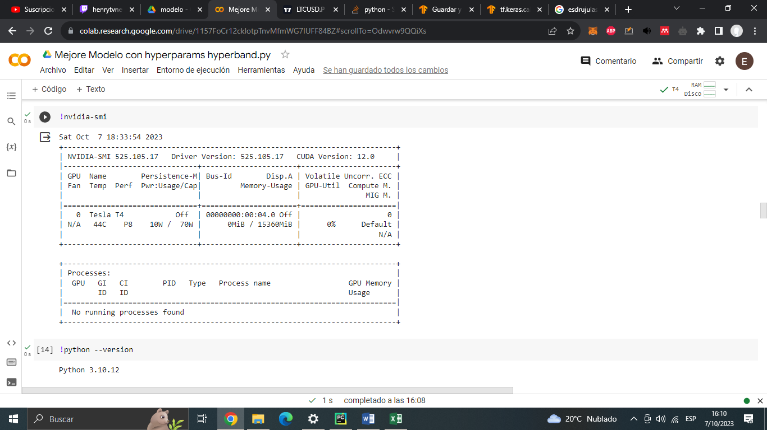

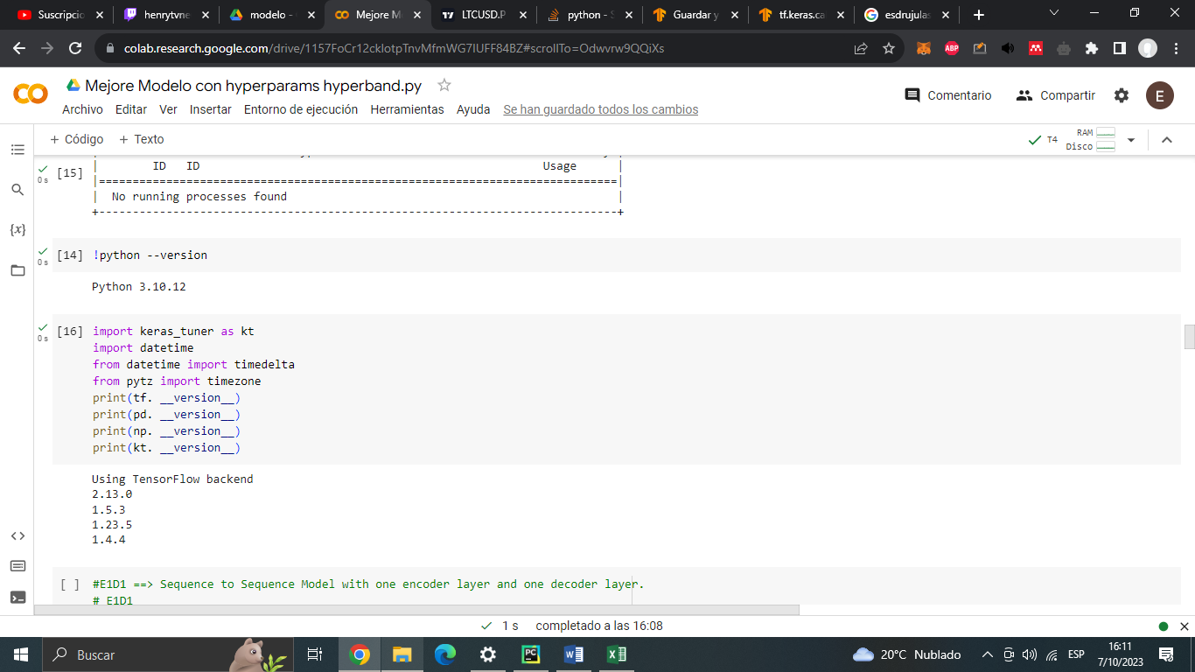

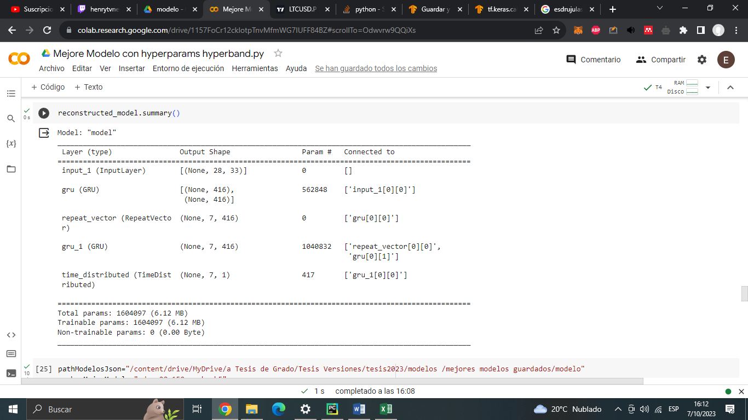

Tiempo Inicio y n_past 2023-10-07 15:45:45 n_past:--> 28

Epoch 1/150

43/43 [==============================] - ETA: 0s - loss: 0.1189Tiempo on_epoch_end 2023-10-07 15:45:51

43/43 [==============================] - 6s 137ms/step - loss: 0.1189 - val_loss: 0.0804

Epoch 2/150

/usr/local/lib/python3.10/dist-packages/keras/src/engine/training.py:3000: UserWarning: You are saving your model as an HDF5 file via `model.save()`. This file format is considered legacy. We recommend using instead the native Keras format, e.g. `model.save('my_model.keras')`.

saving_api.save_model(

43/43 [==============================] - ETA: 0s - loss: 0.1179Tiempo on_epoch_end 2023-10-07 15:46:00

43/43 [==============================] - 9s 201ms/step - loss: 0.1179 - val_loss: 0.0803

Epoch 3/150

43/43 [==============================] - ETA: 0s - loss: 0.1179Tiempo on_epoch_end 2023-10-07 15:46:05

43/43 [==============================] - 5s 114ms/step - loss: 0.1179 - val_loss: 0.0822

Epoch 4/150

43/43 [==============================] - ETA: 0s - loss: 0.1191Tiempo on_epoch_end 2023-10-07 15:46:11

43/43 [==============================] - 6s 137ms/step - loss: 0.1191 - val_loss: 0.0811

Epoch 5/150

43/43 [==============================] - ETA: 0s - loss: 0.1178Tiempo on_epoch_end 2023-10-07 15:46:17

43/43 [==============================] - 6s 137ms/step - loss: 0.1178 - val_loss: 0.0801

Epoch 6/150

43/43 [==============================] - ETA: 0s - loss: 0.1195Tiempo on_epoch_end 2023-10-07 15:46:21

43/43 [==============================] - 5s 113ms/step - loss: 0.1195 - val_loss: 0.0797

Epoch 7/150

43/43 [==============================] - ETA: 0s - loss: 0.1186Tiempo on_epoch_end 2023-10-07 15:46:29

43/43 [==============================] - 7s 170ms/step - loss: 0.1186 - val_loss: 0.0864

Epoch 8/150

43/43 [==============================] - ETA: 0s - loss: 0.1174Tiempo on_epoch_end 2023-10-07 15:46:34

43/43 [==============================] - 5s 110ms/step - loss: 0.1174 - val_loss: 0.0799

Epoch 9/150

43/43 [==============================] - ETA: 0s - loss: 0.1185Tiempo on_epoch_end 2023-10-07 15:46:40

43/43 [==============================] - 6s 150ms/step - loss: 0.1185 - val_loss: 0.0799

Epoch 10/150

43/43 [==============================] - ETA: 0s - loss: 0.1202Tiempo on_epoch_end 2023-10-07 15:46:46

43/43 [==============================] - 6s 133ms/step - loss: 0.1202 - val_loss: 0.0816

Epoch 11/150

43/43 [==============================] - ETA: 0s - loss: 0.1183Tiempo on_epoch_end 2023-10-07 15:46:50

43/43 [==============================] - 5s 111ms/step - loss: 0.1183 - val_loss: 0.0805

Epoch 12/150

43/43 [==============================] - ETA: 0s - loss: 0.1174Tiempo on_epoch_end 2023-10-07 15:46:58

43/43 [==============================] - 7s 167ms/step - loss: 0.1174 - val_loss: 0.0790

Epoch 13/150

43/43 [==============================] - ETA: 0s - loss: 0.1173Tiempo on_epoch_end 2023-10-07 15:47:02

43/43 [==============================] - 5s 112ms/step - loss: 0.1173 - val_loss: 0.0814

Epoch 14/150

43/43 [==============================] - ETA: 0s - loss: 0.1185Tiempo on_epoch_end 2023-10-07 15:47:08

43/43 [==============================] - 6s 139ms/step - loss: 0.1185 - val_loss: 0.0803

Epoch 15/150

43/43 [==============================] - ETA: 0s - loss: 0.1170Tiempo on_epoch_end 2023-10-07 15:47:14

43/43 [==============================] - 6s 137ms/step - loss: 0.1170 - val_loss: 0.0825

Epoch 16/150

43/43 [==============================] - ETA: 0s - loss: 0.1185Tiempo on_epoch_end 2023-10-07 15:47:19

43/43 [==============================] - 5s 110ms/step - loss: 0.1185 - val_loss: 0.0820

Epoch 17/150

43/43 [==============================] - ETA: 0s - loss: 0.1196Tiempo on_epoch_end 2023-10-07 15:47:26

43/43 [==============================] - 7s 172ms/step - loss: 0.1196 - val_loss: 0.0843

Epoch 18/150

43/43 [==============================] - ETA: 0s - loss: 0.1190Tiempo on_epoch_end 2023-10-07 15:47:31

43/43 [==============================] - 5s 112ms/step - loss: 0.1190 - val_loss: 0.0790

Epoch 19/150

43/43 [==============================] - ETA: 0s - loss: 0.1181Tiempo on_epoch_end 2023-10-07 15:47:36

43/43 [==============================] - 5s 125ms/step - loss: 0.1181 - val_loss: 0.0786

Epoch 20/150

43/43 [==============================] - ETA: 0s - loss: 0.1165Tiempo on_epoch_end 2023-10-07 15:47:43

43/43 [==============================] - 6s 146ms/step - loss: 0.1165 - val_loss: 0.0789

Epoch 21/150

43/43 [==============================] - ETA: 0s - loss: 0.1191Tiempo on_epoch_end 2023-10-07 15:47:48

43/43 [==============================] - 5s 113ms/step - loss: 0.1191 - val_loss: 0.0817

Epoch 22/150

43/43 [==============================] - ETA: 0s - loss: 0.1172Tiempo on_epoch_end 2023-10-07 15:47:55

43/43 [==============================] - 7s 163ms/step - loss: 0.1172 - val_loss: 0.0816

Epoch 23/150

43/43 [==============================] - ETA: 0s - loss: 0.1184Tiempo on_epoch_end 2023-10-07 15:47:59

43/43 [==============================] - 5s 110ms/step - loss: 0.1184 - val_loss: 0.0790

Epoch 24/150

43/43 [==============================] - ETA: 0s - loss: 0.1170Tiempo on_epoch_end 2023-10-07 15:48:04

43/43 [==============================] - 5s 117ms/step - loss: 0.1170 - val_loss: 0.0809

Epoch 25/150

43/43 [==============================] - ETA: 0s - loss: 0.1169Tiempo on_epoch_end 2023-10-07 15:48:11

43/43 [==============================] - 7s 155ms/step - loss: 0.1169 - val_loss: 0.0791

Epoch 26/150

43/43 [==============================] - ETA: 0s - loss: 0.1172Tiempo on_epoch_end 2023-10-07 15:48:16

43/43 [==============================] - 5s 112ms/step - loss: 0.1172 - val_loss: 0.0815

Epoch 27/150

43/43 [==============================] - ETA: 0s - loss: 0.1166Tiempo on_epoch_end 2023-10-07 15:48:23

43/43 [==============================] - 7s 172ms/step - loss: 0.1166 - val_loss: 0.0788

Epoch 28/150

43/43 [==============================] - ETA: 0s - loss: 0.1170Tiempo on_epoch_end 2023-10-07 15:48:30

43/43 [==============================] - 7s 156ms/step - loss: 0.1170 - val_loss: 0.0806

Epoch 29/150

43/43 [==============================] - ETA: 0s - loss: 0.1180Tiempo on_epoch_end 2023-10-07 15:48:37

43/43 [==============================] - 7s 154ms/step - loss: 0.1180 - val_loss: 0.0803

Epoch 30/150

43/43 [==============================] - ETA: 0s - loss: 0.1174Tiempo on_epoch_end 2023-10-07 15:48:44

43/43 [==============================] - 7s 162ms/step - loss: 0.1174 - val_loss: 0.0827

Epoch 31/150

43/43 [==============================] - ETA: 0s - loss: 0.1187Tiempo on_epoch_end 2023-10-07 15:48:51

43/43 [==============================] - 7s 165ms/step - loss: 0.1187 - val_loss: 0.0845

Epoch 32/150

43/43 [==============================] - ETA: 0s - loss: 0.1185Tiempo on_epoch_end 2023-10-07 15:48:56

43/43 [==============================] - 6s 127ms/step - loss: 0.1185 - val_loss: 0.0789

Epoch 33/150

43/43 [==============================] - ETA: 0s - loss: 0.1170Tiempo on_epoch_end 2023-10-07 15:49:01

43/43 [==============================] - 5s 111ms/step - loss: 0.1170 - val_loss: 0.0800

Epoch 34/150

43/43 [==============================] - ETA: 0s - loss: 0.1183Tiempo on_epoch_end 2023-10-07 15:49:08

43/43 [==============================] - 7s 167ms/step - loss: 0.1183 - val_loss: 0.0804

Epoch 35/150

43/43 [==============================] - ETA: 0s - loss: 0.1179Tiempo on_epoch_end 2023-10-07 15:49:13

43/43 [==============================] - 5s 112ms/step - loss: 0.1179 - val_loss: 0.0803

Epoch 36/150

43/43 [==============================] - ETA: 0s - loss: 0.1171Tiempo on_epoch_end 2023-10-07 15:49:19

43/43 [==============================] - 6s 144ms/step - loss: 0.1171 - val_loss: 0.0791

Epoch 37/150

43/43 [==============================] - ETA: 0s - loss: 0.1169Tiempo on_epoch_end 2023-10-07 15:49:25

43/43 [==============================] - 6s 132ms/step - loss: 0.1169 - val_loss: 0.0797

Epoch 38/150

43/43 [==============================] - ETA: 0s - loss: 0.1174Tiempo on_epoch_end 2023-10-07 15:49:30

43/43 [==============================] - 5s 109ms/step - loss: 0.1174 - val_loss: 0.0789

Epoch 39/150

43/43 [==============================] - ETA: 0s - loss: 0.1185Tiempo on_epoch_end 2023-10-07 15:49:37

43/43 [==============================] - 7s 163ms/step - loss: 0.1185 - val_loss: 0.0828

Epoch 40/150

43/43 [==============================] - ETA: 0s - loss: 0.1175Tiempo on_epoch_end 2023-10-07 15:49:41

43/43 [==============================] - 5s 110ms/step - loss: 0.1175 - val_loss: 0.0826

Epoch 41/150

43/43 [==============================] - ETA: 0s - loss: 0.1168Tiempo on_epoch_end 2023-10-07 15:49:47

43/43 [==============================] - 6s 129ms/step - loss: 0.1168 - val_loss: 0.0792

Epoch 42/150

43/43 [==============================] - ETA: 0s - loss: 0.1165Tiempo on_epoch_end 2023-10-07 15:49:53

43/43 [==============================] - 6s 140ms/step - loss: 0.1165 - val_loss: 0.0802

Epoch 43/150

43/43 [==============================] - ETA: 0s - loss: 0.1176Tiempo on_epoch_end 2023-10-07 15:49:58

43/43 [==============================] - 5s 109ms/step - loss: 0.1176 - val_loss: 0.0791

Epoch 44/150

43/43 [==============================] - ETA: 0s - loss: 0.1168Tiempo on_epoch_end 2023-10-07 15:50:05

43/43 [==============================] - 7s 167ms/step - loss: 0.1168 - val_loss: 0.0791

Epoch 45/150

43/43 [==============================] - ETA: 0s - loss: 0.1168Tiempo on_epoch_end 2023-10-07 15:50:10

43/43 [==============================] - 5s 112ms/step - loss: 0.1168 - val_loss: 0.0794

Epoch 46/150

43/43 [==============================] - ETA: 0s - loss: 0.1175Tiempo on_epoch_end 2023-10-07 15:50:14

43/43 [==============================] - 5s 112ms/step - loss: 0.1175 - val_loss: 0.0798

Epoch 47/150

43/43 [==============================] - ETA: 0s - loss: 0.1172Tiempo on_epoch_end 2023-10-07 15:50:22

43/43 [==============================] - 7s 164ms/step - loss: 0.1172 - val_loss: 0.0812

Epoch 48/150

43/43 [==============================] - ETA: 0s - loss: 0.1168Tiempo on_epoch_end 2023-10-07 15:50:26

43/43 [==============================] - 5s 113ms/step - loss: 0.1168 - val_loss: 0.0797

Epoch 49/150

43/43 [==============================] - ETA: 0s - loss: 0.1164Tiempo on_epoch_end 2023-10-07 15:50:33

43/43 [==============================] - 7s 165ms/step - loss: 0.1164 - val_loss: 0.0792

Epoch 50/150

43/43 [==============================] - ETA: 0s - loss: 0.1179Tiempo on_epoch_end 2023-10-07 15:50:38

43/43 [==============================] - 5s 109ms/step - loss: 0.1179 - val_loss: 0.0791

Epoch 51/150

43/43 [==============================] - ETA: 0s - loss: 0.1173Tiempo on_epoch_end 2023-10-07 15:50:43

43/43 [==============================] - 5s 111ms/step - loss: 0.1173 - val_loss: 0.0815

Epoch 52/150

43/43 [==============================] - ETA: 0s - loss: 0.1173Tiempo on_epoch_end 2023-10-07 15:50:50

43/43 [==============================] - 7s 165ms/step - loss: 0.1173 - val_loss: 0.0840

Epoch 53/150

43/43 [==============================] - ETA: 0s - loss: 0.1171Tiempo on_epoch_end 2023-10-07 15:50:55

43/43 [==============================] - 5s 114ms/step - loss: 0.1171 - val_loss: 0.0787

Epoch 54/150

43/43 [==============================] - ETA: 0s - loss: 0.1173Tiempo on_epoch_end 2023-10-07 15:51:02

43/43 [==============================] - 7s 167ms/step - loss: 0.1173 - val_loss: 0.0818

Epoch 55/150

43/43 [==============================] - ETA: 0s - loss: 0.1172Tiempo on_epoch_end 2023-10-07 15:51:07

43/43 [==============================] - 5s 113ms/step - loss: 0.1172 - val_loss: 0.0816

Epoch 56/150

43/43 [==============================] - ETA: 0s - loss: 0.1172Tiempo on_epoch_end 2023-10-07 15:51:12

43/43 [==============================] - 5s 123ms/step - loss: 0.1172 - val_loss: 0.0819

Epoch 57/150

43/43 [==============================] - ETA: 0s - loss: 0.1182Tiempo on_epoch_end 2023-10-07 15:51:21

43/43 [==============================] - 9s 209ms/step - loss: 0.1182 - val_loss: 0.0786

Epoch 58/150

43/43 [==============================] - ETA: 0s - loss: 0.1174Tiempo on_epoch_end 2023-10-07 15:51:26

43/43 [==============================] - 5s 116ms/step - loss: 0.1174 - val_loss: 0.0817

Epoch 59/150

43/43 [==============================] - ETA: 0s - loss: 0.1174Tiempo on_epoch_end 2023-10-07 15:51:32

43/43 [==============================] - 6s 138ms/step - loss: 0.1174 - val_loss: 0.0816

Epoch 60/150

43/43 [==============================] - ETA: 0s - loss: 0.1183Tiempo on_epoch_end 2023-10-07 15:51:40

43/43 [==============================] - 8s 186ms/step - loss: 0.1183 - val_loss: 0.0819

Epoch 61/150

43/43 [==============================] - ETA: 0s - loss: 0.1184Tiempo on_epoch_end 2023-10-07 15:51:45

43/43 [==============================] - 5s 112ms/step - loss: 0.1184 - val_loss: 0.0826

Epoch 62/150

43/43 [==============================] - ETA: 0s - loss: 0.1183Tiempo on_epoch_end 2023-10-07 15:51:52

43/43 [==============================] - 7s 164ms/step - loss: 0.1183 - val_loss: 0.0803

Epoch 63/150

43/43 [==============================] - ETA: 0s - loss: 0.1170Tiempo on_epoch_end 2023-10-07 15:51:57

43/43 [==============================] - 5s 110ms/step - loss: 0.1170 - val_loss: 0.0796

Epoch 64/150

43/43 [==============================] - ETA: 0s - loss: 0.1169Tiempo on_epoch_end 2023-10-07 15:52:02

43/43 [==============================] - 5s 115ms/step - loss: 0.1169 - val_loss: 0.0799

Epoch 65/150

43/43 [==============================] - ETA: 0s - loss: 0.1177Tiempo on_epoch_end 2023-10-07 15:52:09

43/43 [==============================] - 7s 159ms/step - loss: 0.1177 - val_loss: 0.0798

Epoch 66/150

43/43 [==============================] - ETA: 0s - loss: 0.1180Tiempo on_epoch_end 2023-10-07 15:52:13

43/43 [==============================] - 5s 114ms/step - loss: 0.1180 - val_loss: 0.0829

Epoch 67/150

43/43 [==============================] - ETA: 0s - loss: 0.1167Tiempo on_epoch_end 2023-10-07 15:52:21

43/43 [==============================] - 7s 168ms/step - loss: 0.1167 - val_loss: 0.0804

Epoch 68/150

43/43 [==============================] - ETA: 0s - loss: 0.1180Tiempo on_epoch_end 2023-10-07 15:52:26

43/43 [==============================] - 5s 114ms/step - loss: 0.1180 - val_loss: 0.0792

Epoch 69/150

43/43 [==============================] - ETA: 0s - loss: 0.1171Tiempo on_epoch_end 2023-10-07 15:52:31

43/43 [==============================] - 5s 120ms/step - loss: 0.1171 - val_loss: 0.0818

Epoch 70/150

43/43 [==============================] - ETA: 0s - loss: 0.1181Tiempo on_epoch_end 2023-10-07 15:52:38

43/43 [==============================] - 7s 158ms/step - loss: 0.1181 - val_loss: 0.0809

Epoch 71/150

43/43 [==============================] - ETA: 0s - loss: 0.1174Tiempo on_epoch_end 2023-10-07 15:52:42

43/43 [==============================] - 5s 114ms/step - loss: 0.1174 - val_loss: 0.0788

Epoch 72/150

43/43 [==============================] - ETA: 0s - loss: 0.1180Tiempo on_epoch_end 2023-10-07 15:52:49

43/43 [==============================] - 7s 166ms/step - loss: 0.1180 - val_loss: 0.0817

Epoch 73/150

43/43 [==============================] - ETA: 0s - loss: 0.1186Tiempo on_epoch_end 2023-10-07 15:52:54

43/43 [==============================] - 5s 111ms/step - loss: 0.1186 - val_loss: 0.0793

Epoch 74/150

43/43 [==============================] - ETA: 0s - loss: 0.1167Tiempo on_epoch_end 2023-10-07 15:52:59

43/43 [==============================] - 5s 115ms/step - loss: 0.1167 - val_loss: 0.0789

Epoch 75/150

43/43 [==============================] - ETA: 0s - loss: 0.1187Tiempo on_epoch_end 2023-10-07 15:53:06

43/43 [==============================] - 7s 161ms/step - loss: 0.1187 - val_loss: 0.0851

Epoch 76/150

43/43 [==============================] - ETA: 0s - loss: 0.1200Tiempo on_epoch_end 2023-10-07 15:53:11

43/43 [==============================] - 5s 113ms/step - loss: 0.1200 - val_loss: 0.0811

Epoch 77/150

43/43 [==============================] - ETA: 0s - loss: 0.1182Tiempo on_epoch_end 2023-10-07 15:53:18

43/43 [==============================] - 7s 167ms/step - loss: 0.1182 - val_loss: 0.0803

Epoch 78/150

43/43 [==============================] - ETA: 0s - loss: 0.1173Tiempo on_epoch_end 2023-10-07 15:53:23

43/43 [==============================] - 5s 113ms/step - loss: 0.1173 - val_loss: 0.0795

Epoch 79/150

43/43 [==============================] - ETA: 0s - loss: 0.1169Tiempo on_epoch_end 2023-10-07 15:53:28

43/43 [==============================] - 5s 114ms/step - loss: 0.1169 - val_loss: 0.0805

Epoch 80/150

43/43 [==============================] - ETA: 0s - loss: 0.1180Tiempo on_epoch_end 2023-10-07 15:53:35

43/43 [==============================] - 7s 166ms/step - loss: 0.1180 - val_loss: 0.0805

Epoch 81/150

43/43 [==============================] - ETA: 0s - loss: 0.1175Tiempo on_epoch_end 2023-10-07 15:53:40

43/43 [==============================] - 5s 116ms/step - loss: 0.1175 - val_loss: 0.0825

Epoch 82/150

43/43 [==============================] - ETA: 0s - loss: 0.1168Tiempo on_epoch_end 2023-10-07 15:53:47

43/43 [==============================] - 7s 157ms/step - loss: 0.1168 - val_loss: 0.0824

Epoch 83/150

43/43 [==============================] - ETA: 0s - loss: 0.1176Tiempo on_epoch_end 2023-10-07 15:53:52

43/43 [==============================] - 5s 117ms/step - loss: 0.1176 - val_loss: 0.0807

Epoch 84/150

43/43 [==============================] - ETA: 0s - loss: 0.1183Tiempo on_epoch_end 2023-10-07 15:53:57

43/43 [==============================] - 5s 112ms/step - loss: 0.1183 - val_loss: 0.0795

Epoch 85/150

43/43 [==============================] - ETA: 0s - loss: 0.1167Tiempo on_epoch_end 2023-10-07 15:54:06

43/43 [==============================] - 9s 212ms/step - loss: 0.1167 - val_loss: 0.0816

Epoch 86/150

43/43 [==============================] - ETA: 0s - loss: 0.1176Tiempo on_epoch_end 2023-10-07 15:54:11

43/43 [==============================] - 5s 118ms/step - loss: 0.1176 - val_loss: 0.0799

Epoch 87/150

43/43 [==============================] - ETA: 0s - loss: 0.1170Tiempo on_epoch_end 2023-10-07 15:54:18

43/43 [==============================] - 7s 170ms/step - loss: 0.1170 - val_loss: 0.0801

Epoch 88/150

43/43 [==============================] - ETA: 0s - loss: 0.1176Tiempo on_epoch_end 2023-10-07 15:54:23

43/43 [==============================] - 5s 115ms/step - loss: 0.1176 - val_loss: 0.0804

Epoch 89/150

43/43 [==============================] - ETA: 0s - loss: 0.1173Tiempo on_epoch_end 2023-10-07 15:54:30

43/43 [==============================] - 7s 159ms/step - loss: 0.1173 - val_loss: 0.0797

Epoch 90/150

43/43 [==============================] - ETA: 0s - loss: 0.1174Tiempo on_epoch_end 2023-10-07 15:54:38

43/43 [==============================] - 7s 171ms/step - loss: 0.1174 - val_loss: 0.0827

Epoch 91/150

43/43 [==============================] - ETA: 0s - loss: 0.1181Tiempo on_epoch_end 2023-10-07 15:54:42

43/43 [==============================] - 5s 111ms/step - loss: 0.1181 - val_loss: 0.0812

Epoch 92/150

43/43 [==============================] - ETA: 0s - loss: 0.1171Tiempo on_epoch_end 2023-10-07 15:54:49

43/43 [==============================] - 7s 165ms/step - loss: 0.1171 - val_loss: 0.0835

Epoch 93/150

43/43 [==============================] - ETA: 0s - loss: 0.1172Tiempo on_epoch_end 2023-10-07 15:54:54

43/43 [==============================] - 5s 113ms/step - loss: 0.1172 - val_loss: 0.0799

Epoch 94/150

43/43 [==============================] - ETA: 0s - loss: 0.1170Tiempo on_epoch_end 2023-10-07 15:54:59

43/43 [==============================] - 5s 115ms/step - loss: 0.1170 - val_loss: 0.0786

Epoch 95/150

43/43 [==============================] - ETA: 0s - loss: 0.1178Tiempo on_epoch_end 2023-10-07 15:55:06

43/43 [==============================] - 7s 171ms/step - loss: 0.1178 - val_loss: 0.0795

Epoch 96/150

43/43 [==============================] - ETA: 0s - loss: 0.1178Tiempo on_epoch_end 2023-10-07 15:55:11

43/43 [==============================] - 5s 115ms/step - loss: 0.1178 - val_loss: 0.0821

Epoch 97/150

43/43 [==============================] - ETA: 0s - loss: 0.1187Tiempo on_epoch_end 2023-10-07 15:55:19

43/43 [==============================] - 7s 166ms/step - loss: 0.1187 - val_loss: 0.0802

Epoch 98/150

43/43 [==============================] - ETA: 0s - loss: 0.1167Tiempo on_epoch_end 2023-10-07 15:55:23

43/43 [==============================] - 5s 110ms/step - loss: 0.1167 - val_loss: 0.0797

Epoch 99/150

43/43 [==============================] - ETA: 0s - loss: 0.1175Tiempo on_epoch_end 2023-10-07 15:55:28

43/43 [==============================] - 5s 113ms/step - loss: 0.1175 - val_loss: 0.0803

Epoch 100/150

43/43 [==============================] - ETA: 0s - loss: 0.1169Tiempo on_epoch_end 2023-10-07 15:55:35

43/43 [==============================] - 7s 164ms/step - loss: 0.1169 - val_loss: 0.0786

Epoch 101/150

43/43 [==============================] - ETA: 0s - loss: 0.1167Tiempo on_epoch_end 2023-10-07 15:55:40

43/43 [==============================] - 5s 112ms/step - loss: 0.1167 - val_loss: 0.0834

Epoch 102/150

43/43 [==============================] - ETA: 0s - loss: 0.1174Tiempo on_epoch_end 2023-10-07 15:55:47

43/43 [==============================] - 7s 162ms/step - loss: 0.1174 - val_loss: 0.0797

Epoch 103/150

43/43 [==============================] - ETA: 0s - loss: 0.1175Tiempo on_epoch_end 2023-10-07 15:55:52

43/43 [==============================] - 5s 117ms/step - loss: 0.1175 - val_loss: 0.0842

Epoch 104/150

43/43 [==============================] - ETA: 0s - loss: 0.1171Tiempo on_epoch_end 2023-10-07 15:55:57

43/43 [==============================] - 5s 114ms/step - loss: 0.1171 - val_loss: 0.0843

Epoch 105/150

43/43 [==============================] - ETA: 0s - loss: 0.1184Tiempo on_epoch_end 2023-10-07 15:56:04

43/43 [==============================] - 7s 167ms/step - loss: 0.1184 - val_loss: 0.0808

Epoch 106/150

43/43 [==============================] - ETA: 0s - loss: 0.1179Tiempo on_epoch_end 2023-10-07 15:56:09

43/43 [==============================] - 5s 116ms/step - loss: 0.1179 - val_loss: 0.0811

Epoch 107/150

43/43 [==============================] - ETA: 0s - loss: 0.1178Tiempo on_epoch_end 2023-10-07 15:56:16

43/43 [==============================] - 7s 164ms/step - loss: 0.1178 - val_loss: 0.0795

Tiempo Final y n_past 2023-10-07 15:56:16 n_past:--> 28

Modelo despues de 107 epocas empeoró levemente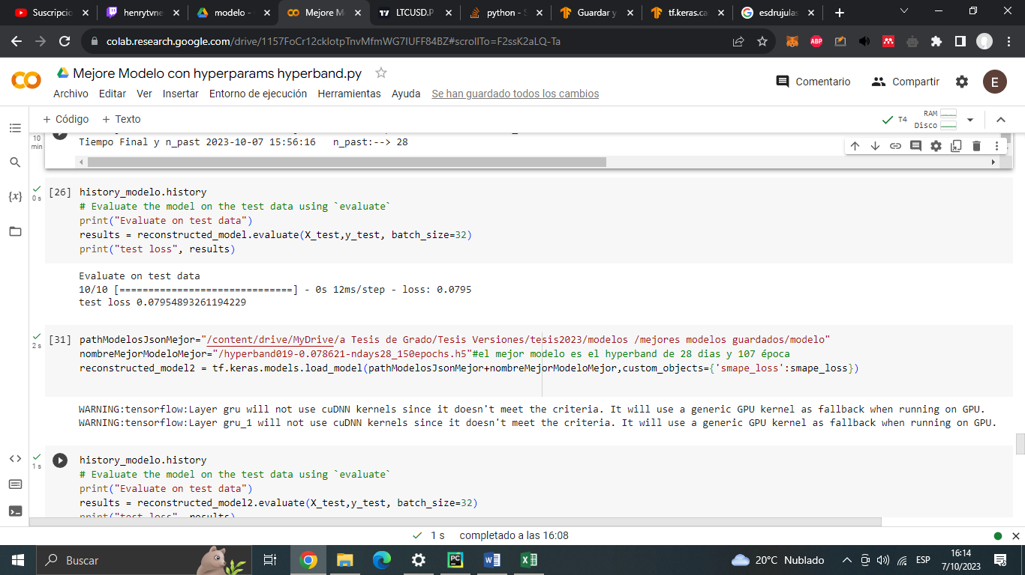

Mejor modelo de la mejor epoca de 107 fue el de la época 57

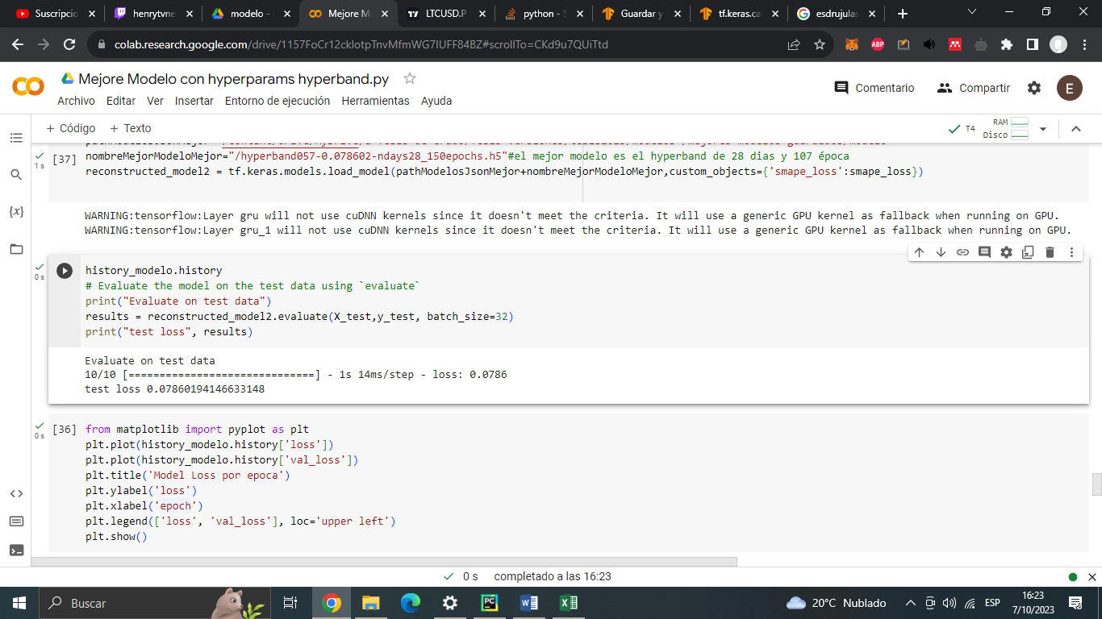

Model.evaluate sirve para evaluar el modelo con los datos de test, es decir el 20%

Anterior mejor modelo de hyperband era: 0.07861421257257462->-(1-0.0786…)*100->92.138

El obtenido es de: 0.07860194146633148 ->-(1-0.0786…)*100->92.139

El porcentaje de mejora fue de: 92,13857874 % de acierto a 92,13980585% de acierto

Siendo un 0,00122711% de mejora en acierto total

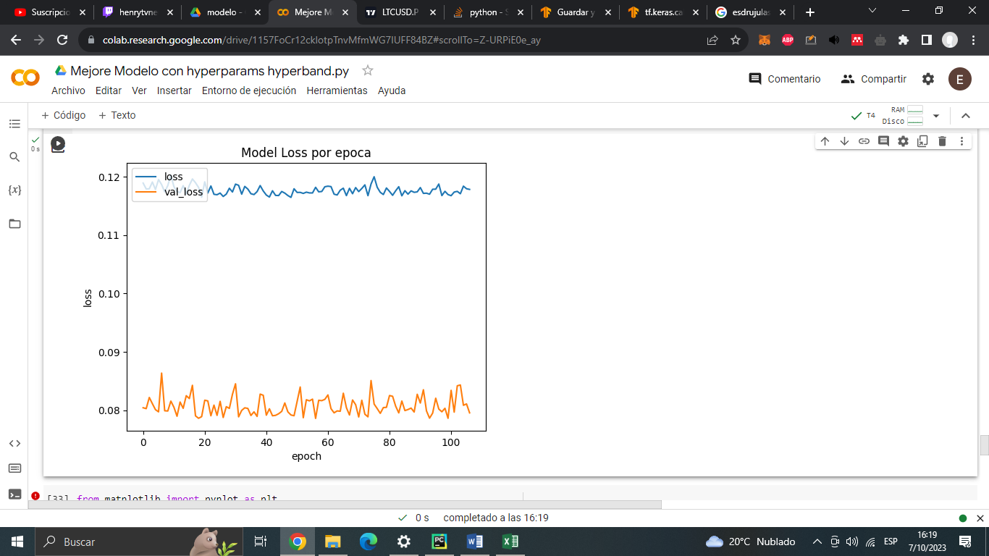

En la imagen se puede ver que desde la época 57 no mejora el rendimiento entonces cortó el entrenamiento en la época 107

Notas: se supone que es bueno que el modelo tenga mejor val_loss que loss porque el val_loss es de prueba y el otro es de entrenamiento por lo que sería una evidencia de que el modelo no está sobreentrenado/ overfitting(agregar fuente)

Palabras buscadas sobre EarlyStopping patience

EarlyStopping patience lstm

En este paper <https://aclanthology.org/P17-2035.pdf>

Neural Architecture for Temporal Relation Extraction:

A Bi-LSTM Approach for Detecting Narrative Containers

dicen “we implemented early stopping with a patience of 10 epochs without performance improvement”

En este otro paper <https://ieeexplore.ieee.org/abstract/document/8972270> también usan

Virtual Quality control using bidirectional LSTM

networks and gradient boosting 2019

“Our model up to this stage is a bidirectional LSTM trained with early stopping to prevent overfitting. Early stopping will determine the number of training epochs.”

“This final model is a bidirectional LSTM with 2 cells in the input layer of each LSTM trained with early stopping (patience of 5 epoch)”

En este otro paper <https://link.springer.com/article/10.1007/s13131-021-1763-9>

Multi-step ahead short-term predictions of storm surge level using CNN and LSTM network 2021

Mencionan un EarlyStopping patience de 5

# Evaluación del modelo

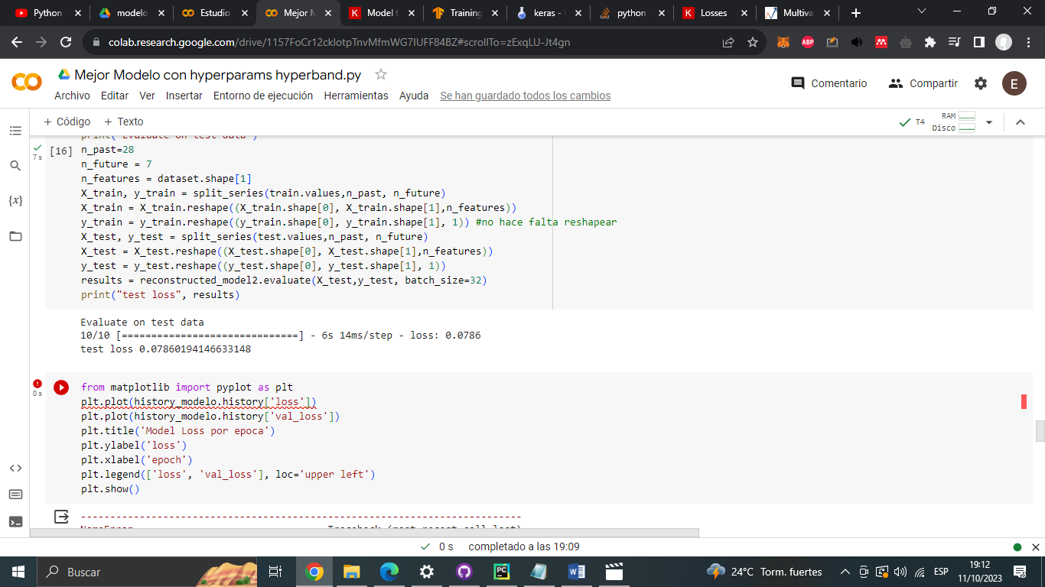

Por la función integrada evaluate el resultado es 0.07860

Según la página de donde saque gran parte del código del modelo

<https://www.analyticsvidhya.com/blog/2020/10/multivariate-multi-step-time-series-forecasting-using-stacked-lstm-sequence-to-sequence-autoencoder-in-tensorflow-2-0-keras/>

se evalúa por día

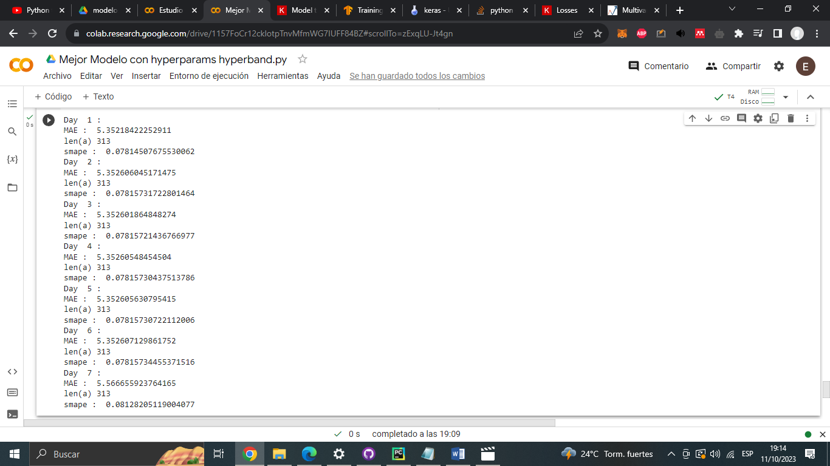

Donde array de dia comparado con array de dia se obtienen resultados parecidos

Nose si se se evalua asi (a investigar)

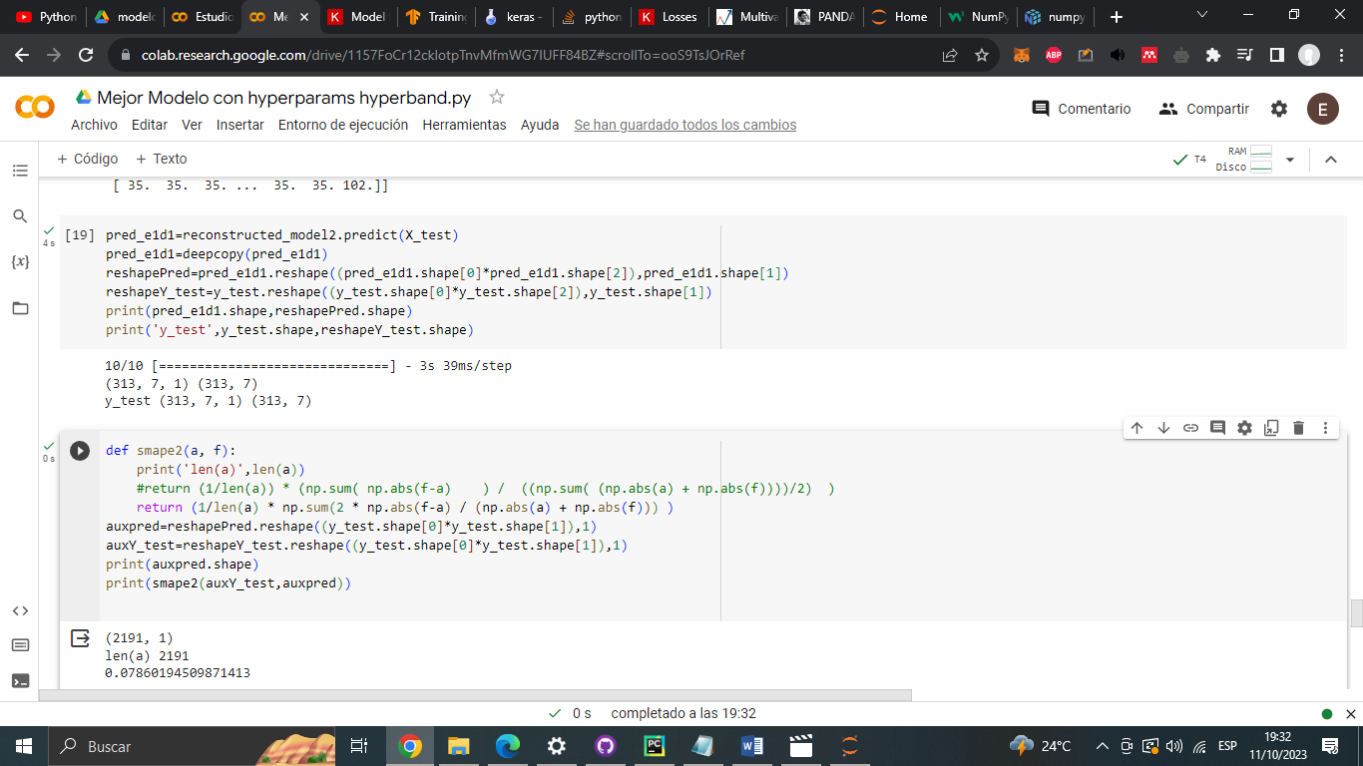

Cada dia 313X test y 313Y test en un total de 7 dias

Si le hago un reshape tengo como resultado todos los días unidos me da 2191 valores en un solo array de los datos X test y un array en Y test también shape (2191,1)

Si a esos array le aplico la formula SMAPE obtengo 0.078601 lo que es un buen resultado, el mismo de hecho del evaluate.

Básicamente si hago que me prediga el xtest y luego le aplico el smape obtengo lo mismo que con el evaluate

Ya sea que evalue por dia en promedio los resultados son de 0.0782 - 0.0812 según lo visto

El problema está en que viendo los datos de salida del predict solo hay números de 35 es decir pronostica al predictor flag que tenga 35,.. y decimales no logre ver que pronostique ni mas ni menos